Print out Rows and Columns on Every Page with the Date and other information.

When you want to print out your spreadsheet you may want the column headings or row headings to appear on every page as well as other information like the date or the file name. To do this follow the steps below.

Go to Format > Print Ranges > Edit

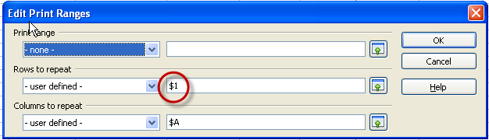

By clicking in the Rows to repeat and then on the Column or Row that want repeated it will automatically select the entire row or column.

If you want to print just a selected area of the Calc Sheet you can use the Print Range option. Click in the box to the right of - none - and then click on the Calc sheet and drag to select the range you want printed.



